DAILY TREASURY
LOGIC MANUAL

Created By Kresnoadi
Created On 20/08/2009

Table Structure

No | Table Name
1 | DT_JenisPengeluaran
2 | DT_Bank
3 | DT_JenisTransaksi
4 | DT_PengajuanHeader
5 | DT_PengajuanDetail
6 | DT_KonfirmasiHeader
7 | DT_KonfirmasiDetail
8 | DT_ClosingPengajuan
9 | DT_ClosingKonfirmasi
10 | SYS_SourceOfDoc_Hdr
11 | SYS_SourceOfDoc_Dtl

Login

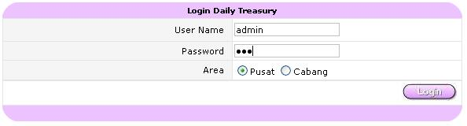

Expense Type List

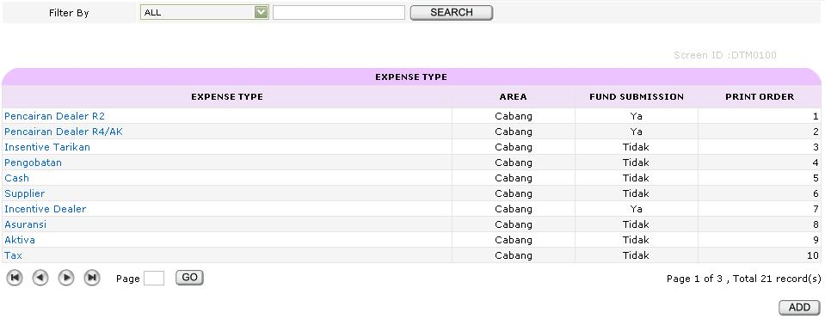

Search Filter
- Expense Type
- Print Priority

Hyperlink
- Expense Type
  - Link ke Expense Type Input

Button
- Add
  - Link ke Expense Type Input

Expense Type View

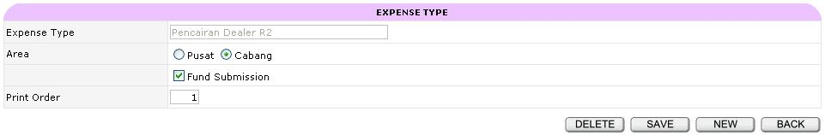

Button
- New
  - Link ke Expense Type View
- Save
  - Insert data ke DT_JenisPengeluaran
  - Link ke Expense Type List
- Delete
  - Delete data dari DT_JenisPengeluaran
  - Link ke Expense Type List
- Back
  - Link ke Expense Type List

Validation
    - Expense Type tidak boleh sama
    - Area yang dipilih akan berpengaruh pada Expense Type yang bisa dipilih di Transaksi
    - Print Order tidak boleh sama

Bank and Transaction Type Input

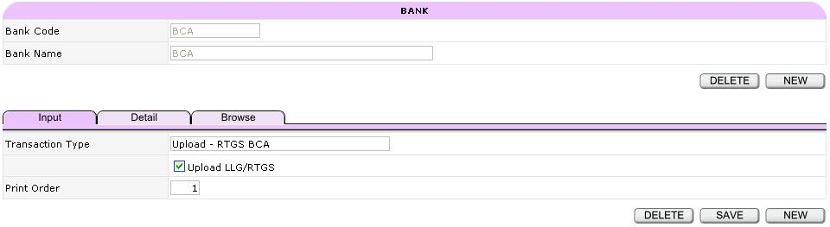

Button
Top
- New
  - Link ke Bank Input
- Delete
  - Delete data dari FC_TransactionType by NoDataBank
  - Delete data dari FC_Bank

Bottom
- New
  - Link ke Bank Input
- Save
  - Insert data ke FC_Bank
  - Insert data ke FC_TransactionType
  - Link ke Bank Input
- Delete
  - Delete data dari FC_TransactionType
  - Link ke Bank Input

Tabulation
- Detail
  - Link ke Bank Detail
- Browse
  - Link ke Bank Browse

Validation
- Bank Code tidak boleh sama
- Transaction Type tidak boleh sama
- Upload LLG/RTGS akan berpengaruh pada Transaction Type yang bisa dipilih di Transaksi
- Print Order tidak boleh sama

Bank and Transaction Type Detail

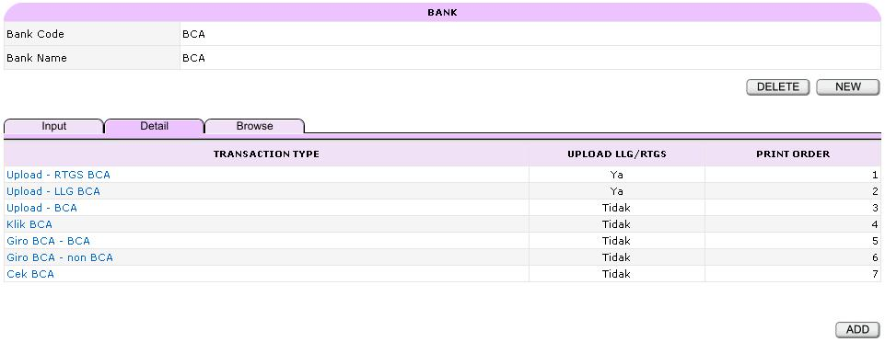
Hyperlink
- Transaction Type
  - Link ke Bank Input

Button
Top
- New
  - Link ke Bank Input
- Delete
  - Delete data dari DT_TransactionType
  - Delete data dari DT_Bank
  - Link ke Bank Input

Bottom
- Add
  - Link ke Bank Input

Tabulation
- Input
  - Link ke Bank Input
- Browse
  - Link ke Bank Browse

Bank and Transaction Type Browse

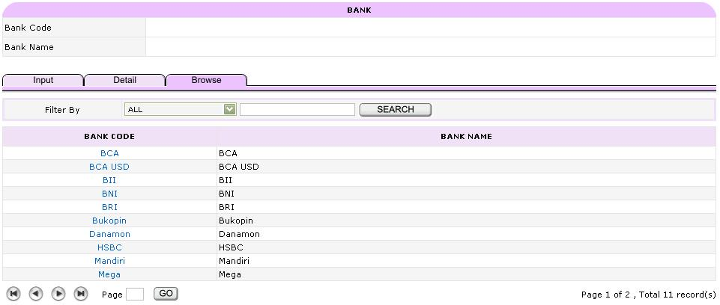

Search Filter
- Bank Code
- Bank Name

Hyperlink
- Bank Code
  - Link ke Bank Detail

Tabulation
- Input
  - Link ke Bank Input
- Detail
  - Link ke Bank Detail

Fund Request Submission Input

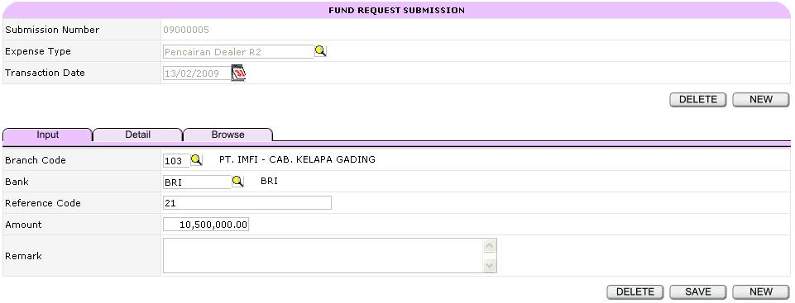

Button
Top
- New
  - Link ke Fund Request Submission Input
- Delete
  - Delete data dari FC_PengajuanDetail
  - Delete data dari FC_PengajuanHeader
  - Link ke Fund Request Submission Input

Bottom
- New
  - Fund Request Submission Input
- Save
  - Insert data ke FC_PengajuanHeader
  - Insert data ke FC_PengajuanDetail
  - Link ke Fund Request Submission Input
- Delete
  - Delete data dari FC_PengajuanDetail
  - Link ke Fund Request Submission Input

Tabulation
- Detail
  - Link ke Fund Request Submission Detail
- Browse
  - Link ke Fund Request Submission Browse

Validation
- Submission Number akan otomatis terisi
- Expense type yang bisa dipilih sesuai dengan Area yang dipilih pada saat login
- Save dan Delete aktif selama Transaction Date belum Closed

Fund Request Submission Detail

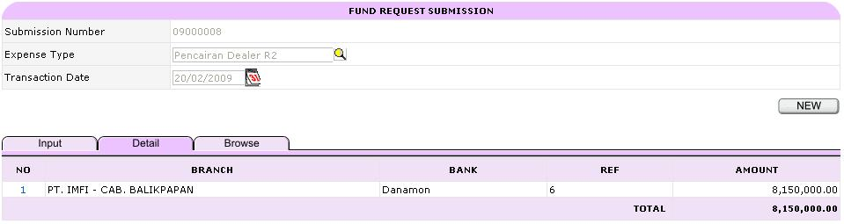

Hyperlink
- No
  - Link ke Fund Request Submission Input

Button
Top
- New
  - Link ke Fund Request Submission Input
- Delete
  - Delete data dari FC_PengajuanDetail
  - Delete data dari FC_PengajuanHeader
  - Link ke Fund Request Submission Input

Bottom
- Add
  - Link ke Fund Request Submission Input

Tabulation
- Input
  - Link ke Fund Request Submission Input
- Browse
  - Fund Request Submission Browse

Validation
- Delete aktif apabila Submission belum Konfirmasi
- Delete aktif selama Transaction Date belum Closed
- Add aktif apabila Submission belum Konfirmasi

Fund Request Submission Browse

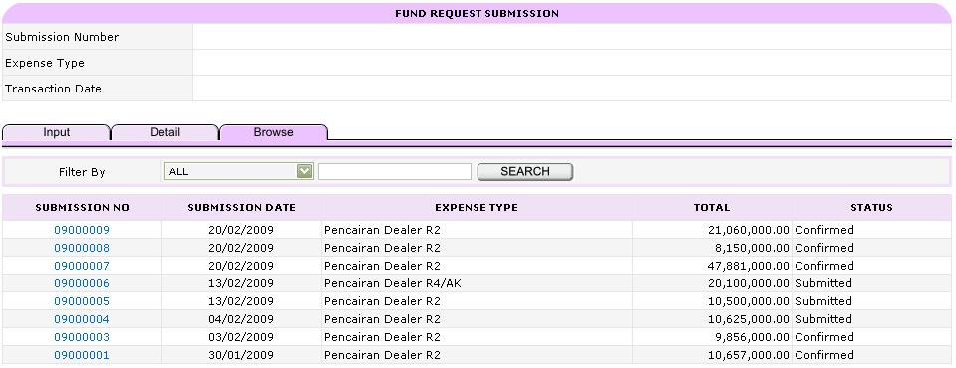

Search Filter
- Submission Number
- Expense Type

Hyperlink
- Submission Number
  - Link ke Fund Request Submission Browse

Tabulation
- Input
  - Link ke Fund Request Submission Input
- Detail
  - Link ke Fund Request Submission Detail

Fund Request Confirmation Input

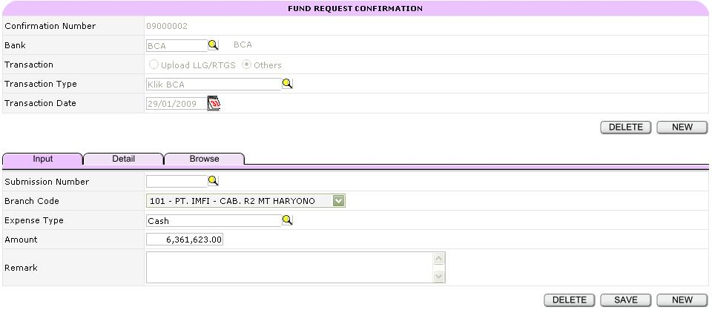

Button
Top
- New
  - Link ke Fund Request Confirmation Input
- Delete
  - Delete data dari DT_KonfirmasiDetail
  - Delete data dari DT_KonfirmasiHeader
  - Link ke Fund Request Confirmation Input

Bottom
- New
  - Link ke Fund Request Confirmation Input
- Save
  - Insert data ke DT_KonfirmasiHeader
  - Insert data ke DT_KonfirmasiDetail
  - Link ke Fund Request Confirmation Input
- Delete
  - Delete data dari DT_KonfirmasiDetail
  - Link ke Fund Request Confirmation Input

Tabulation
- Detail
  - Link ke Fund Request Confirmation Detail
- Browse
  - Link ke Fund Request Confirmation Browse

Validation
- Confirmation Number akan otomatis terisi
- Submission Number dapat tidak diisi (optional)
- Branch Code yang bisa dipilih sesuai dengan branch yang diinput pada Submission yang dipilih (bila mengisi Submission Number, maka akan ditampilkan seluruh cabang)
- Save dan Delete aktif selama Transaction Date belum Closed

Fund Request Confirmation Detail

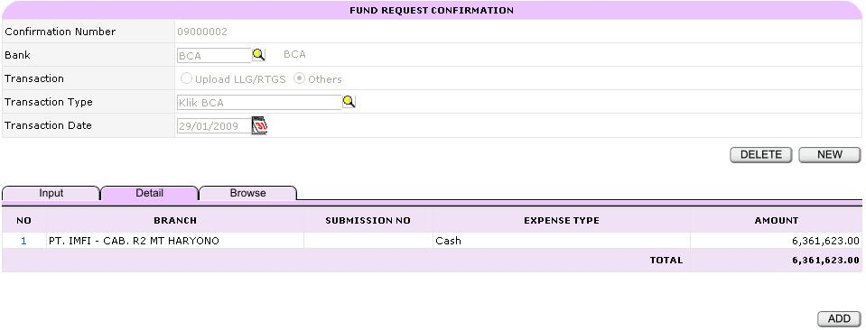

Hyperlink
- No
  - Link ke Fund Request Confirmation Input

Button
Top
- New
  - Link ke Fund Request Confirmation Input
- Delete
  - Delete data dari FC_KonfirmasiDetail
  - Delete data dari FC_KonfirmasiHeader
  - Link ke Fund Request Confirmation Input

Bottom
- Add
  - Link ke Fund Request Confirmation Input

Tabulation
- Input
  - Link ke Fund Request Confirmation Input
- Browse
  - Fund Request Confirmation Browse

Validation
- Delete aktif selama Confirmation Date belum Closed

Fund Request Confirmation Browse

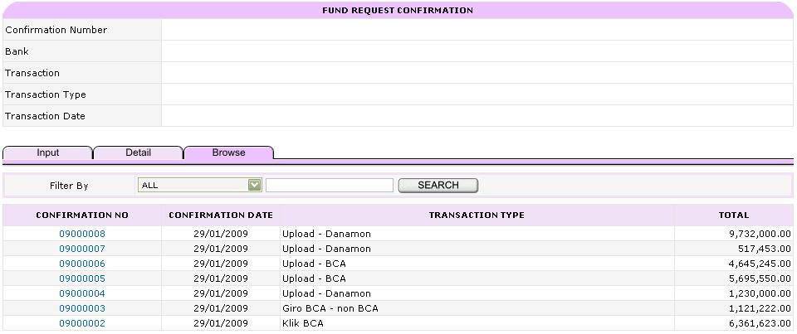

Search Filter
- Confirmation Number
- Transaction Type

Hyperlink
- Confirmation Number
  - Link ke Fund Request Confirmation Detail

Tabulation
- Input
  - Link ke Fund Request Confirmation Input
- Detail
  - Link ke Fund Request Confirmation Detail

Fund Request Submission Day Period Manager

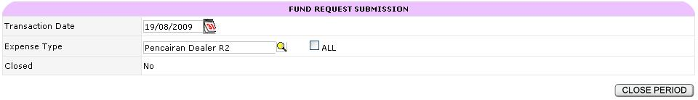

Button
- Close Period
  - Update data DT_ClosingPengajuan
- Open Prev Period
  - Update data DT_ClosingPengajuan

Fund Request Confirmation Day Period Manager

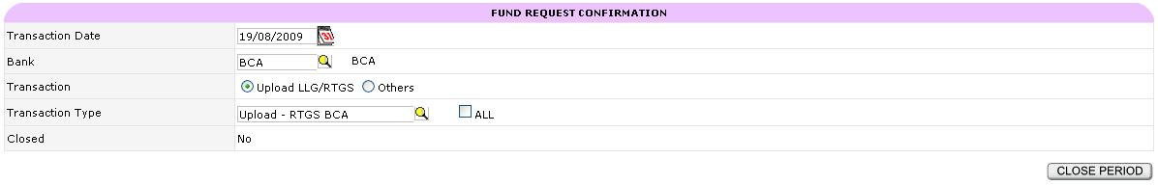

Button
- Close Period
  - Update data DT_ClosingPengajuan
- Open Prev Period
  - Update data DT_ClosingKonfirmasi

